**Sponsor: Dr. Badri Roysam (IEEE UH Makers)**

University of Houston

Dept. of Electrical & Computer Engineering

N308 Engineering Bldg 1

4726 Calhoun Rd

Houston, TX 77204-4005

Phone: 713-743-4435

Sent to: [broysam@central.uh.edu](mailto:broysam@central.uh.edu)

Cc: [litvinov@uh.edu](mailto:litvinov@uh.edu)

April 9th, 2019

Greetings Dr. Roysam,

We want to thank you again for approving our IEEE UH Makers and Team 16 senior design project, Knuckles, the assistive robotic arm. The arm was presented at the Capstone Design Conference on April, 26th at the Hilton, thank you for attending.

Unfortunately, our project got damaged during the shipping. We mitigated that issue and finalized the final prototype. We are able to control the motors using Arduino and Rviz. The robot is fully built. However, we have three defective motors, we know which ones we need and will communicate the specs to the next Senior Design team.We installed the camera mount on the physical arm. We are able to receive text commands through voice commands. We successfully linked all the modules together except for the GUI. Our project is now capable to accomplish an automated and autonomous system.

We are extremely grateful for your continued support of our research.

If you have any questions or concerns, please feel free to contact us.

Sincerely,

Team 16

Andrew Blanchard (Team Leader), Matthew van Zuilekom, Rym Benchaabane, Paola Hernandez

# Team 16

# Knuckles, Assistive Robotic Arm

# Sponsor: Dr. Badri Roysam (IEEE UH Makers)

# Facilitator: Dr. Dmitri Litvinov

# Faculty Advisor: Dr. Aaron Becker

# Friday, May 3rd 2019

# Final Report

# Andrew Blanchard (Team Leader), Matthew van Zuilekom, Paola Hernandez, Rym Benchaabane

# 

# 

# 

**Purpose and Need**

Knuckles is an assistive robotic arm that will hand the user requested objects and tools through voice command. It will serve as a convenient assistant that will increase the user’s productivity and decrease the risk of dexterity incidents. The problem is that multitasking causes a lack of focus on a task which results to a waste time, money, and can also lead to serious injury. What is needed is a solution that allows the user to continue with their task without distractions, and can assist the user as needed. The extra hand will allow one to focus on the work without having to get up and grab another tool, which saves one time and effort in completing the current task.

**Overview Diagram and Background**

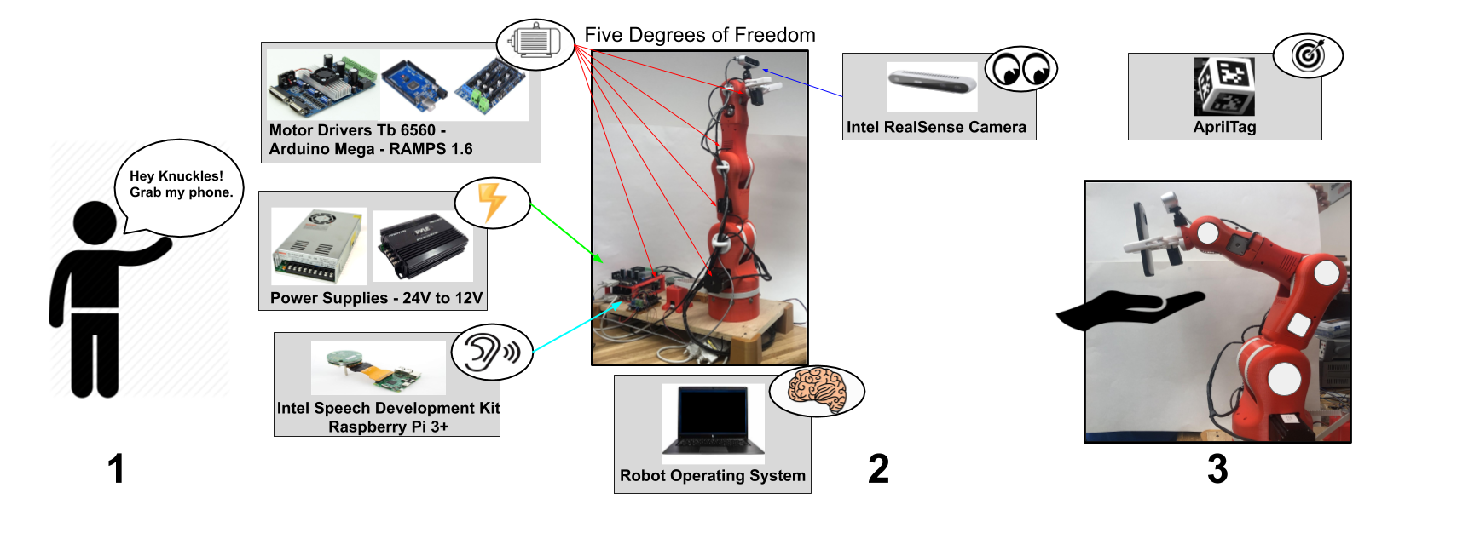

**Figure 1. Overview diagram of Knuckles functionalities**

Knuckles will be able to respond to voice commands and retrieve requested objects for the user. To accomplish this, we will connect a microphone to a RaspBerry Pi3+ which will start listening for a voice command once the user has said “Alexa trigger Knuckles to ...” Voice commands will be converted to text using the Amazon Alexa Voice Service, to be interpreted by ROS on a main computer, which the RaspBerry Pi3+ is also connected. From there, the main computer will connect to an Arduino MEGA & RAMPS 1.4 combination, which is connected to the motors used to control the arm. An Intel RealSense camera will be attached to the gripper of the robot arm, which will be used to locate the requested object. An AprilTag will on each requestable object, which is what the camera will be looking for.

In today’s society, people are rushed and tend to multitask. According to research from the scientific journal, *Current Biology[1]*, shifting focus and attempting to multitask reduces productivity by around 40%. *SMF Mutual Insurance* adds that multitasking can lead to dexterity incidents while performing hands-on work.[2]

The problem is that multitasking causes a lack of focus on a task which results to a waste time, money, and can also lead to serious injury. What is needed is a solution that allows the user to continue with their task without distractions, and can assist the user as needed. The extra hand will allow one to focus on the work without having to get up and grab another tool, which saves one time and effort in completing the current task. Figure 1 represents Knuckles’ ability to respond to voice commands and hand the requested object to the user.

Our device will be used by users doing hands-on work who are unable to step away from their work, or users with disabilities. It can be operated by most in the general public, as the method to control it will simply be voice commands, which most people are capable of. The user will need minimal expertise, as they will need to know to say “Alexa trigger Knuckles to ...” to have the arm start listening for voice commands, and they will need to know how to structure the command.

**Design Considerations**

**Figure 3. Design diagram and interactions between parts of the project**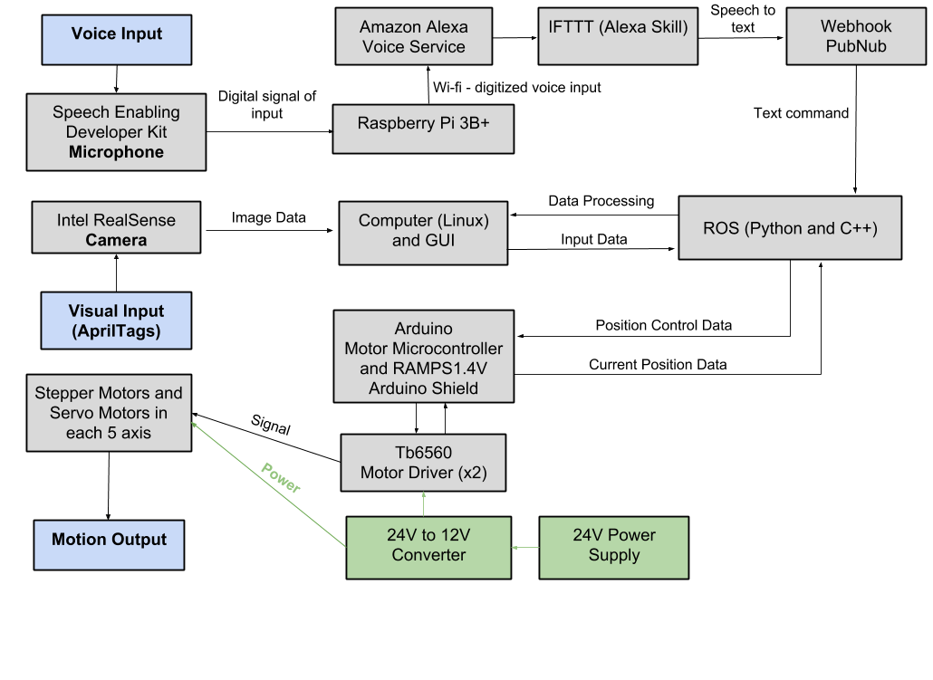

Initially, we were planning to use a 3D object detection program using the depth camera and a point cloud. However, with the inclusion of AprilTags, we can simply use the tags to get the object position in the received image, and also calculate the distance of the gripper to the tag, which was the purpose of the 3D object detection program. Thus, we implemented AprilTags to receive and deliver an object to the user. We have decided to use an Intel Speech Enabling Developer Kit as our omni-directional microphone to process speech to text. Knuckles is able to recognize and pick up 9 objects. The user can request an object from anywhere in the room using the omnidirectional feature of the microphone. As for the power system, Knuckles is designed as a home robot so we adapted it to 120[V] mains. The reason why we have a 24V to 12V converter is because we have two NEMA 17 motors that can handle 24V. We quickly realized after testing the motors that the steppers motors work fine with 12V. Every other hardware device working with the motors require at least 12V.

For the arm, we 3D printed ring taps for a better wire routing system. We also 3D printed cases for the hardware as a protection. We centralized everything onto a carved wooden base.

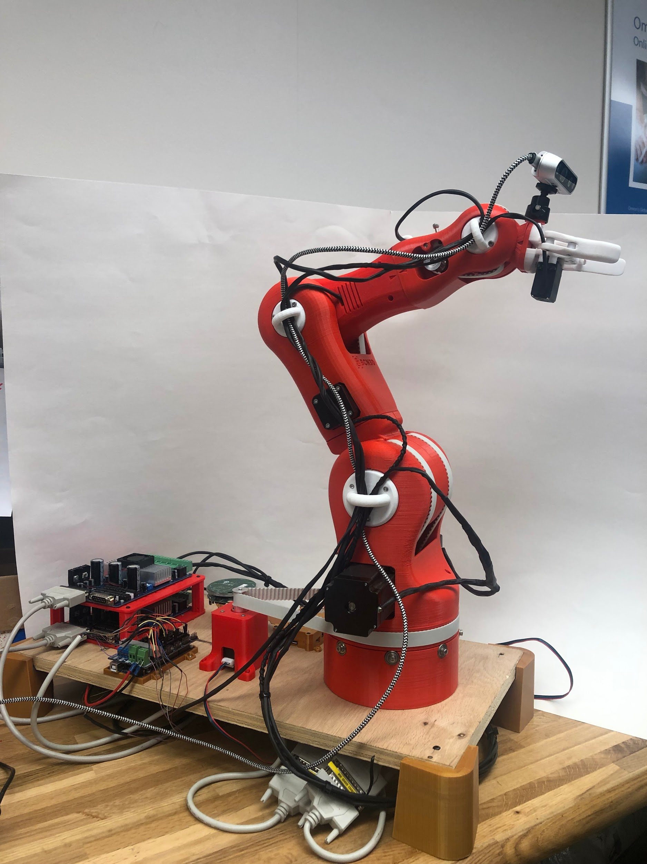

**Figure 4. Knuckles in default position with 3D printed ring taps and cases**

We also implemented a user interface to make Knuckles’ sequence status visible and easier way to troubleshoot any errors. The GUI gives the user the option to give text commands instead of voice as well.

**Figure 5. Graphical User Interface**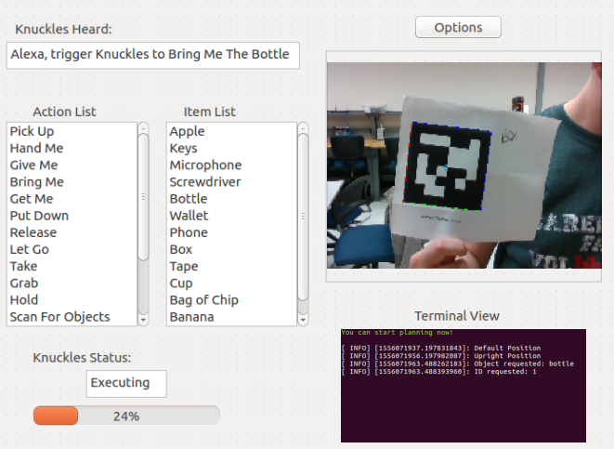

**Design Constraints**

Our main design constraint is the time allotted to develop a gripper that’s capable of grabbing a larger range of objects. In addition, due to the strength of our motors, we are only able to lift a limited weight, which is listed in our specifications. We had some tremendous limitations in our motors. We found three new motors that are able to withstand the new weights. Besides, Knuckles is a stationary robot and does not have a long reach. This problem can be covered in future works. The fact that Knuckles is 3D-printed makes the robot delicate and heavy as well.

**Deliverables and Test Plan**

**Table 1: Deliverables Progress and Test Plan**

|  |  |  |  |  |
| --- | --- | --- | --- | --- |
| **Goal Status** | **Goal Description** | **Goal Modifications** | **Test Plan** | **Issues** |
| **Completed** | This allows us to confirm the arm is moving correctly and free, before applying software to it. The mechanical properties of Knuckles are divided into two components, the arm and the gripper. | None | **Test the mobility of the robot:**  Verify the arm and gripper motion with a controller. This arm uses seven motors: six to control the movement of the arm, and one to control the gripper. The controller will be able to control each of these motors individually by changing the polarity and magnitude of the voltage across each of the motors. Two of the six motors used to control the arm will control the same movement at the base of the gripper, so the controller will have to control those two motors at the same time as well | We had a significant delay ordering the necessary parts as we were doing it through IEEE UH Makers, which caused the construction of the arm to be delayed. |
| **Completed** | The goal was to have the arm properly communicating with ROS, and be able to control the entire arm using this software.  We are connecting the arm’s joints with a total of 6 stepper motors (2 for the base). These motors will be processed by ROS and controlled by Arduino. The Arduino has a add-on motor shield RAMPS1.4V. The TB6560 is the motor driver that is going to be directly wired to the motors and RAMPS1.4V. The RAMPS1.4V is powered by a 24V to 12V converter and this converter is connected to a 24V power supply. We have a breadboard as a center of power connections. | None | **Test robot connection to ROS:**  Request the robot to position itself in straight up, straight out,  and in reaching motions. The test will be successful if these basic movements are shown in both the simulation and the physical arm. | None |
| **Completed** | This is a major part of the project. Rviz is able to visualize as many tags as we can fit in the camera view, and is able to remember the object position once it has left the camera view. It provides the object translation/location in the camera view, the orientation of the object, and the object distance from the camera. The visual processing for Knuckles is handled using RViz and AprilTags. Knuckles will utilize the Intel RealSense Depth Camera D435. | We decided to use AprilTags instead to simplify our project. AprilTags allows our camera to easily locate an object in the room, and provides the position of the object in the camera view and also allows us to calculate the distance away from the object. RViz is our 3D visualization application for ROS that will work with the Intel Camera. | **Test object recognition with AprilTags:**  Validate the simulation can recognize multiple objects at the same time. We will verify that different frame will surround the different visible objects without naming them yet. | We initially planned to use OpenCV & TensorFlow for this. However, due to complications using a non-ROS program and trying to have it communicate with ROS |
| **Completed** | AprilTags are able to accomplish this much more easily, without having to create a point cloud of the entire environment. We can simply find the tag position in the environment. Instead, Rviz will map the specific location of the AprilTags, rather than mapping the entire environment. | None | **Test the ability of the robot to map the environment:**  Compare map data representation to that of the workspace of the robot. Through this we we test the object localization, and recognize the various objects around the arm. | None |
| **Completed** | The robot is able to associate AprilTag to an object name and detect it.  The gripper should be able to grab the object. | Usage of AprilTag instead of actual objects. | **Test the object search function:**  Use text recognition to have the robot point at objects. This will serve as the initial point where the robot responds to commands. The robot should be able to properly respond to 8 objects.  **Test the object retrieval function:**  Use text recognition to retrieve an object. | None |
| **Completed** | Implement a communication system with Intel Speech Development Kit, Raspberry Pi 3+ and ROS to make Knuckles process voice commands. | None | **Tests the voice recognition:**  Compare voice commands to the text in the ROS terminal.  **Test the user search function:**  Upon voice request, have the robot find the user. | None |
| **Completed** | The gripper should be able to grab the object and return the object | None | **Test the return function:**  Have the robot drop the object as close to the user as possible.  **Test the gripper with the return:**  Have the robot wait until the user is within range and pulls on the object. | None |
| **Completed** | Make the robot react and complete task 7 seconds | None | **Test the timing of the entire process:** Our goal is for the arm to be able to locate the correct object and grab within 7 seconds. | None |
| **In progress** | Create a GUI for the user to interact with Knuckles | None | **Test the responsiveness and communication between GUI and Knuckles:**  Press a home button to have Knuckles stand straight in an initial position.  Verify text commands and all 8 object identities. | None |

**Specifications and Features**

**Table 2: Specifications and Features**

|  |  |
| --- | --- |
| **Specifications** | **Features** |
| Degrees of Freedom (DOF) Arm – Five | Powered by Mains – Yes |
| Accuracy Voice Interpretation – 95% | Integrated Microphone – Yes |
| Minimum Voltage for Motors – 12V | Integrated Camera – Yes |
| Object Detection – AprilTags | Object Detection with AprilTags |
| Object Count Library – 9 | Voice-Controlled using Alexa Voice Service – Yes |
| Responsiveness Range – 4 meters | GUI-Controlled – Yes |
| Response Time – 7 seconds | Wi-Fi required – Yes |
| Maximum Grabbing Reach – 0.5 meter |  |
| Maximum Weight Rating – 0.5 kg |  |

**Schedule and Gantt Chart**

In the Gantt charts below:

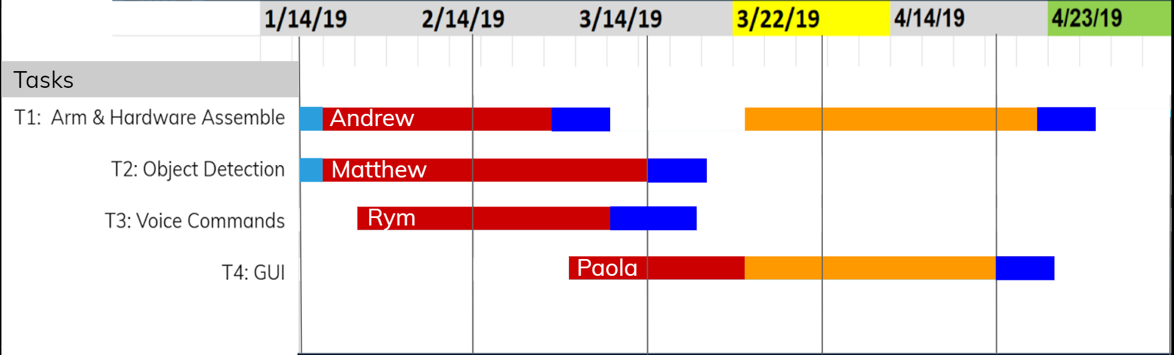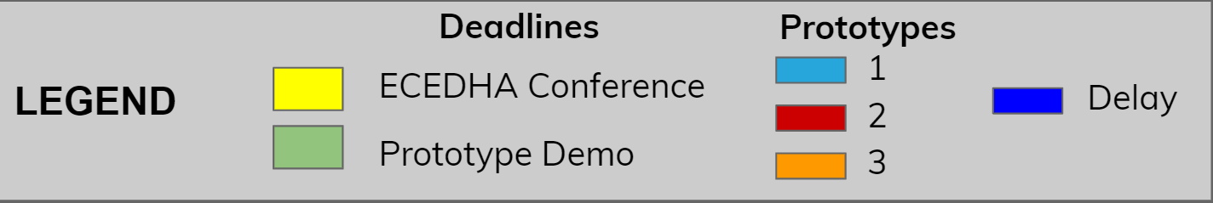

**Figure 6: Spring semester Gantt chart**

**Total Budget**

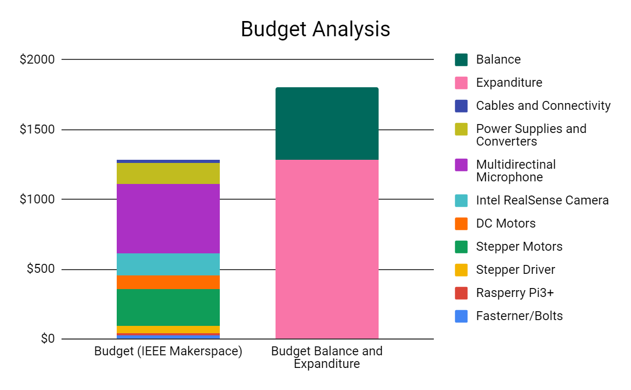

**Figure 7: Graphical representation of total budget**

We would like to thank our sponsors, IEEE UH Makers and Dr. Becker for making this project possible. All of the parts needed in order to finish constructing Knuckles have arrived, and we do not expect to make more purchases. Also, we appreciate the help of Dr. Becker, by allowing us to use his 3D printers from his research lab that has been very beneficial for our project. Overall, our total budget is $1,800, however, we have a current balance of $517, and have expended $1283, which is around 70% of our budget. Any project optimization and improvements are mainly software based rather than hardware. It will require more man hours.

However, since we had to build the third prototype, we used all of our project budget of a total of 1,800$.

**Risk Management and Mitigation**

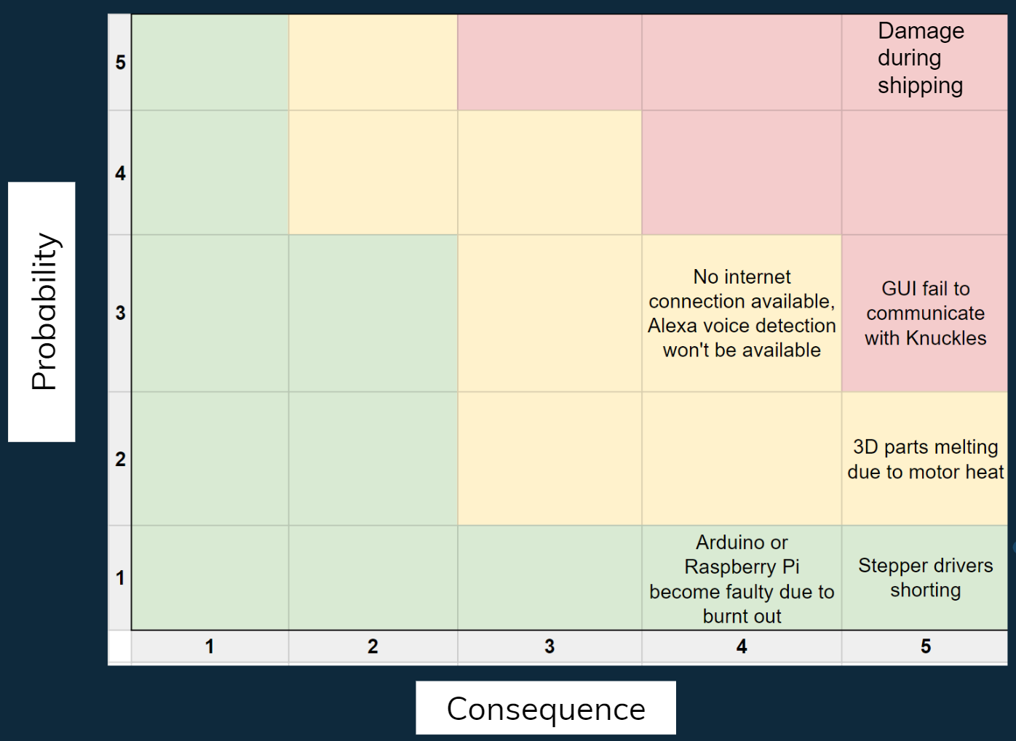

**Figure 8: Risk Matrix**

Pertaining to the risk mitigation: if the GUI fails to communicate with Knuckles, using the voice to text input method can be an option to overcome this issue. If there is no internet connection available, Alexa voice detection will be unavailable but we can overcome this obstacle by using a text input. We can always re-print melted parts in case a 3D part melts due to motor heat. Next, the stepper drivers might short but we have four extra stepper drivers as replacements. Finally, Arduino or Raspberry Pi might become faulty due to burnt out connections but thanks to IEEE UH Makers, we can get replacements for free. During shipping, our project got damaged and lead us to develop the third and final prototype of Knuckles. The mitigation was reprinting the entire arm with extra cost.

**Patent Search**

Patent 1 : MOBILE ROBOT WITH A HEAD-BASED MOVEMENT MAPPING SCHEME 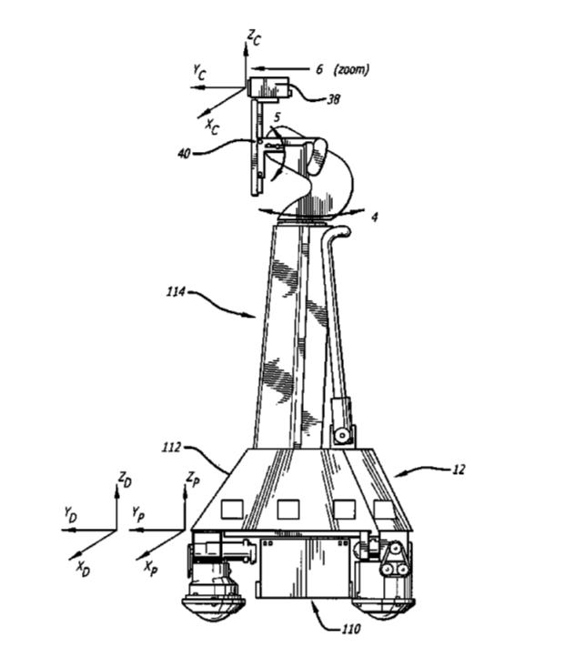

Patent 1 Number: US 8,077,963 B2

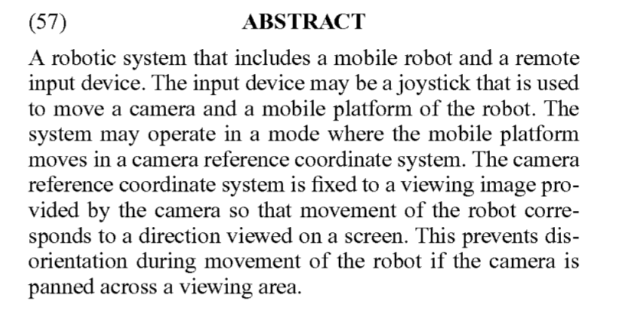

**Figure 9: Patent 1 abstract on the left and robot design on the right**

The claims for this patent consist of a mobile robot system that is controlled through an input device, comprising of a camera located in a camera coordinate system and an input device. The input device is a joystick. The twisting joystick causes rotation of the camera and pivoting causes mobile robot to move. The robot has remote control system with a camera coupled to a monitor.

This patent is similar to our project because it has a head-based movement mapping scheme. However, the base of Knuckles is secured to a stand rather than being mobile. The camera in the patented robot maps the room, while Knuckles uses the camera map and searches for items in the workspace. Next, Knuckles’ camera is fixed to the arm, facing the gripper and cannot be repositioned without human assistance or collision. Knuckles’ movement is controlled by a motion planning framework rather than a joystick.

Patent 2: CONTROL METHOD FOR MACHINES, INCLUDING A SYSTEM, COMPUTER PROGRAM, DATA SIGNAL AND GUI

Patent 2 Number: US 8,417,363 B2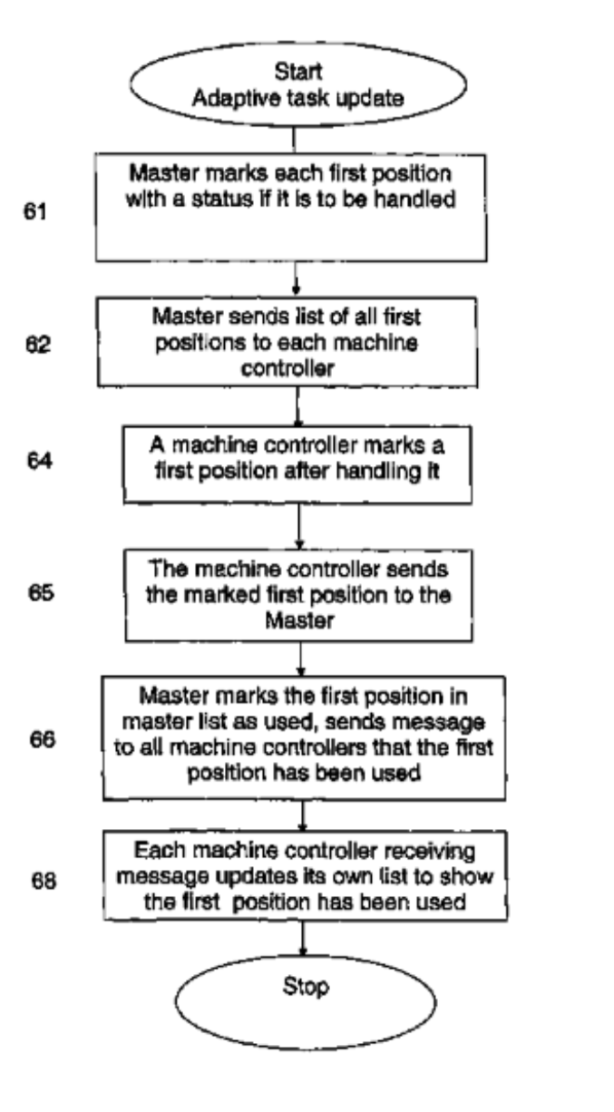

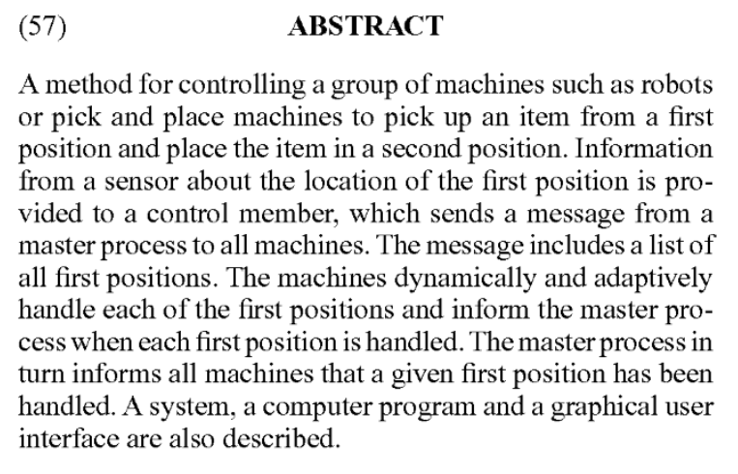

**Figure 10: Patent 2 abstract on the left and design flow chart on the right**

This patent was claimed for several reasons: it is a computer program designed to control a class of robots to pick and place an object while informing a master controller the first and second position before and after picking up the object. This design has a sensor based movement. A graphical user interface (GUI) is also in used to choose and see which positions the robots go to pick up an item.

Knuckles has also a sensor based movement. Knuckles is also computer programmed to pick up objects and only one item could be picked up and released. The patent has hard coded algorithm to specify the location of the object whereas Knuckles depends on the AprilTag detection. The patented algorithm is to control several robots at a time but we are controlling only one.

Patent 3: MACHINE-READABLE DELIVERY PLATFORM FOR AUTOMATED PACKAGE DELIVERY

Patent Number: US 10,242,334 B2

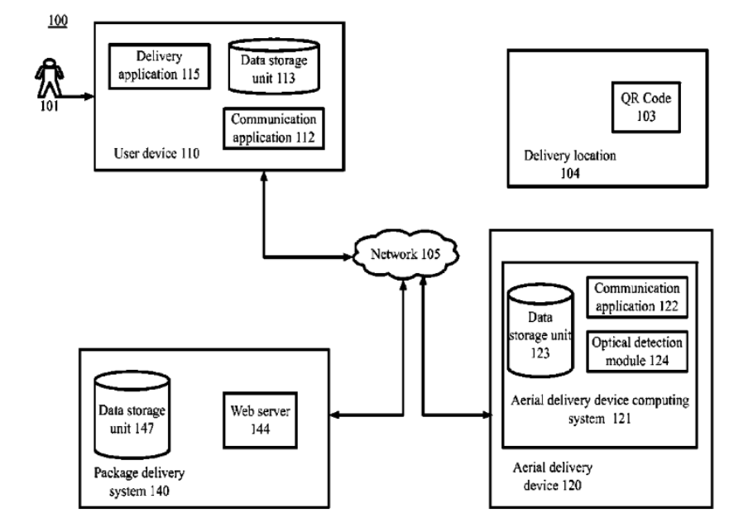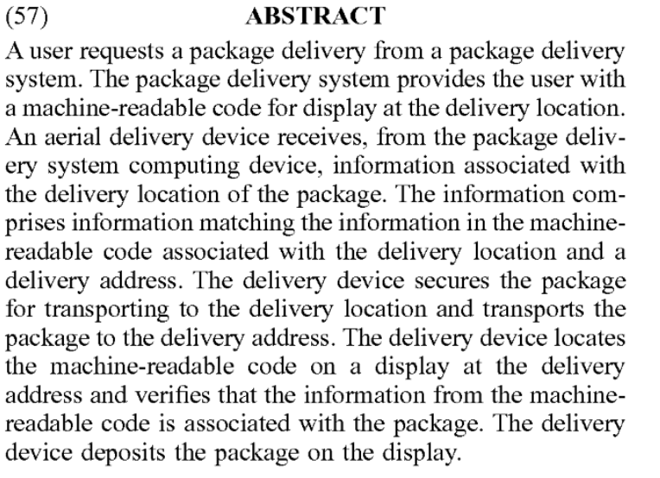

**Figure 9: Patent 3 abstract on the left and design diagram on the right**

Patent 3 claims that is a computer implemented method to automate package deliveries, where delivery location is shown by a printed image for display at a particular location. The delivery location information also contains a GPS location and address. The similarity with our project is that it uses a form of barcode in the patent case a QR code and in our case an AprilTag to detect information about the object. The item is recognized by a camera that located a QR code the same way as Knuckles does. However, this patent is for larger geographical scale applications and Knuckles does not use GPS locations as its workspace is limited to 0.5 meter square.

Patent 4: IDENTIFYING ITEMS IN IMAGES

Patent Number: US 10,223,732 B2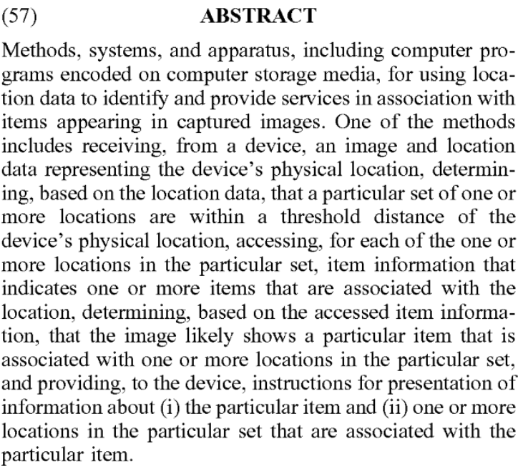

**Figure 10. Patent 4 abstract on the left and overview diagram on the right**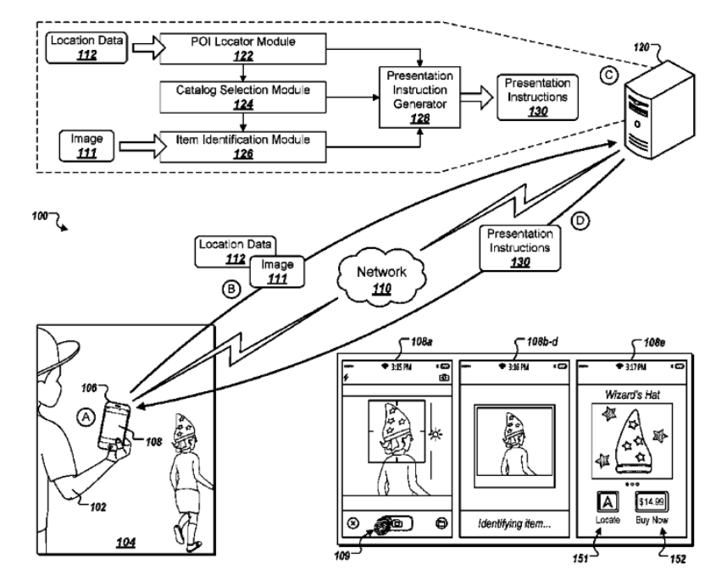

Patent 4 has three main claims. Patent 4 is a computer program specialized on object recognition from an image, and connection to a web browser so find the object in store near the user. This program works with Internet connection and includes a system with clients and servers. The similarities are that we both use object recognition to detect an image. The patent and our project uses a connection to the internet and retrieves information from a server. However, the patent uses the user’s IP address locate him or her to the nearest store whereas Knuckles uses the AprilTag’s location. The system is mostly used for shopping applications but Knuckles is an aid system.

**Project Summary**

Knuckles is an assistive robotic arm that will hand the user requested objects and tools through voice commands. Its purpose is to help increase the user’s productivity and decrease the risk of dexterity accidents. This project combines robotic motion and voice/object detection. Knuckles is a 3D printed five axis robotic arm with a two finger gripper. The arm will be processing a voice input from the Intel Speech Development Microphone, a visual input from the Intel RealSense Camera and a motion output from the Arduino Mega 2560. All the data will be interpreted by the Robot Operating System (ROS) installed on a computer (Linux). The third prototype fully built. The robot can also detect and follow AprilTags in Rviz and grab objects. Knuckles understands voice commands. Our team also started developing The Graphical User Interface (GUI) to have an easier interaction with Knuckles through voice and text commands. Our team used 100% of a 1800$ budget. We would like to thank our sponsor, Dr. Roysam, as well as our faculty advisor Dr. Becker for their generous donations.

Some future works examples to future senior design groups:

* Implementation of object detection and recognition
* Enhancement of position awareness using limiters and encoders
* Conversion of Knuckles to a mobile robot to expand uses
* Upgrade Knuckles' gripper to adapt to a wider range of object shapes
* Improvements on searching methods for user using the multi-directional microphone

Senior design was a great project management exercice.

1. Gross, Michael. “Chronic stress means we’re always on the hunt”. Current Biology, https://www.cell.com/current-biology/fulltext/S0960-9822(14)00489-8
2. Boblard, Lionell. “Injured Workers.” *SFM Mutual Insurance*, [www.sfmic.com/injured-workers/](http://www.sfmic.com/injured-workers/).